Trade in the Ottoman, Mughal, and Safavid Empires
Author: Muhsanah Arefin

Objectives:

This lesson will introduce students to the impact of the Ottoman, Safavid, and Mughal Empires on the Indian Ocean market. This subject represents a crucial, definitive moment in Islamic and world history. This lesson also exposes students to the diversity of non-Arab Islamic empires and the importance of Indo-Persian and Turkish commodities in the world market.

Goals:

- Students will define where and when these empires existed, and why these empires were essential to the development of the global market.
- Students will learn to effectively compare and contrast empires.
- Students will identify key contributions of the Ottomans, Safavids, and Mughals to the world economy.
- Students will learn how all three empires created a network of trade that was mutually beneficial.
- By creating a short presentation, students will exercise their public speaking skills and make connections between historical topics.
- Using the icons on the Indian Ocean maps, students will learn about the relationships each empire maintained with other world powers through trade.
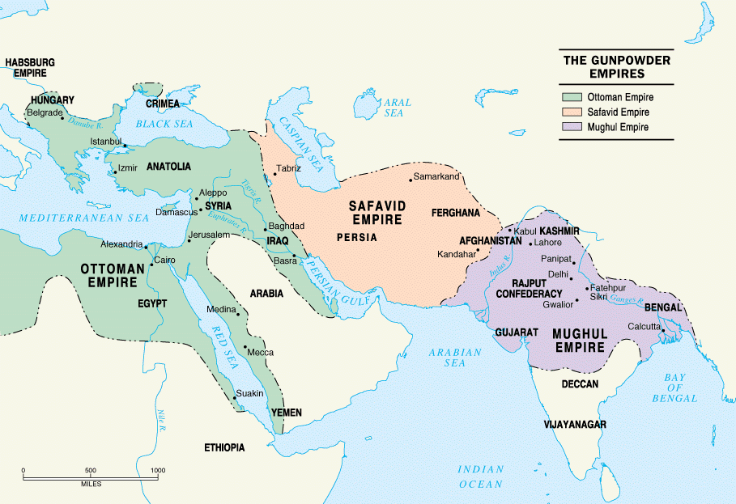
Application: Can be applied in World/Global history courses, AP World History. Grades 9-12.
Duration: 2.5 50 minute classes

Materials:

- Access to computers for students.
- http://indianoceanhistory.org/assets/Site_18/files/BodiesofWater.pdf
- http://indianoceanhistory.org/LessonPlan/FirstGlobalEra.aspx
- http://indianoceanhistory.org/LessonPlan/IndustrialandImperialEra.aspx
- Historical Overview sections of Indian Ocean History Website
- Power point visual
- Worksheet for presentations
- Quiz
Useful Icons:
- First Global Era Map
  - The Safavid empire
  - Persian Carpets (I)
  - Royal decree of Shah Abbas to the English
  - Sidi Reis
  - The Mughal Empire and the Red Fort of Aghra
  - The Mappilas
  - Calcutta
  - Gujarati Traders
  - Mughal Turkey Painting
  - Letter from Jahangir to James of England
  - Bengal and Coromandel Cloth
  - Floral Cotton Chintz
  - Opium
  - Pepper
  - Dungarees
  - Goa
  - Ebony
  - Trade Winds and Horse Latitudes
  - Surat, Gujrat
  - The Ottoman Empire (1299-1922)
  - The Ottoman Navy
- Industrial and Imperial Era Map
  - Muhammed Ali
  - Persian carpets (II)
  - Nablus
  - Jiddah

Section I: For Teachers
Overview (Reference for Teachers):
This overview will summarize important information regarding three coexisting economies connected to Indian Ocean Trade. Both the Ottoman and Mughal empires benefitted from the agricultural revenue of their land, as well as control of trade. Contrastingly, the Safavid Empire relied far more on its trade of raw silk and carpets to account for its minimal farming land. Below are descriptions of each empire, as well as remarks on how the three economies coexisted.
The Ottoman Empire was founded by Nomadic Turkmen chief Osman I in northwestern Anatolia (modern Turkey) in 1299. The Ottomans were military expansionists and the empire grew to control the Balkans, North Africa, and the Levant (modern day Syria, Lebanon, Jordan and Israel). The ruling religion of the Ottoman Empire was Sunni Islam. However, the majority of the empire's subjects were not Muslim until several hundred years into its existence. The Ottoman Empire included large populations of Christians, Jews, and Shi’a (Shiite) Muslims. The political ruler was called a Sultan, which is defined as the one who holds authority. The Ottoman Empire had an economy, which was largely reliant on taxation on agriculture. The Ottomans benefitted from custom taxes and its possession of Bursa, a port city in northwestern Anatolia. Its proximity to both Western Asia and the Mediterranean made for ideal trading conditions. Although the Ottomans did produce their own luxury handicrafts such as silk cloth, their primary source of revenue was from their production of foodstuffs. Only after the acquisition of Egypt and the Levant in the 16th century, over two hundred years into the existence of the empire, did the Ottomans gain a greater diversity of goods to trade such as cotton, textiles, and soap. What remained consistent was the Ottomans’ abundance of grain, which was needed by the likes of Venetian merchants. The Ottoman Empire quickly established connections and developed its naval power in order to control the flow of goods. Ottoman naval power was essential to its trading networks, as the empire worked to protect the seas from privateering and maritime violence. The Ottomans defended the seas by implementing naval patrols and consolidating their hold over trade routes.
The Mughal Empire was founded in the Indian subcontinent (modern day India, Pakistan, and Bangladesh) by Babur in 1526, who became the first emperor. The Mughal Empire was a Sunni Muslim empire, although they ruled over a majority Hindu population. Later on, rulers of the Mughal Empire adopted the Persian title of Shah. The Mughal Empire’s economy was formidable and affluent. The Indian subcontinent and the area under Mughal control was extremely fertile, which led to high agricultural revenue. The Mughal Empire imported very little, aside from horses. It was able to manufacture everyday supplies and foodstuffs. This positive trade balance allowed the empire to flourish. Other popular Indian exports included indigo, rice, spices, muslin, pepper, ebony, and ivory. Additionally, India was a major producer of high quality cotton. Although Ottomans and Safavids also produced cotton, Indian cloth was preferred and had a higher value in the global market. High popularity of Indian products led to the steady flow of European silver into the empire. This flow of European silver was fundamental to the minting of imperial coin.
The Safavid Empire was founded in Tabriz, Persia (modern day Iran), founded by Shah Ismail I in 1501. The political and religious leader of the Safavid Empire is called a Shah, which translates to king. Unlike the neighboring Ottoman Empire, the religion of the Safavid Empire was Shi’i Islam. The Safavid Empire had an ideal geographic location for trade, with a long coastline between Arabia and India. A major export of the Safavid Empire was its raw silk and silk textiles. Persian carpets were also especially popular in Europe during the modern period. Persia has had a long history of producing luxurious carpets, beginning in the 6th century. This tradition continued for years but increased demand in the 16th century outside the Indian Ocean region greatly aided the Safavid trading network. In Safavid Persia, production centers for carpets such as Isfahan, Khorasan, and Fars thrived. Industries related to carpet making thrived as well, such as woodwork for looms. The Safavids, unlike the Ottomans and Mughals, did not have an abundance of resources. The geographical conditions of the Iranian plateau forced Safavid Shahs, like Shah Abbas I, to develop the economy through trade. Shah Abbas is credited with establishing infrastructure and institutions to protect caravan routes such as highway police and bridges. He also attempted to develop other domestic industries like cotton, indigo, and rice in order to reduce dependency on Indian imports.
To summarize, all three empires were somewhat similar in their methodologies of acquiring state fortune. What made them differ in wealth was their ability to balance the output of their exports and imports. Additionally, the fertility of the land affected their ability to fund their empires. The Ottomans gained much of their agricultural revenue from the lucrative region of Rumelia in the Balkans as the land was quite fertile. For the Mughals, they had access to the fertile Indus River valley region and Punjab. As mentioned earlier, there are commodities sold across the region that were equally important to all three empires, such as silk and cotton. Another similarity the three empires had was that important trading groups were often non-Muslim. For example, Christian Armenians were essential mercantilists in the Ottoman and Safavid empires. In the Mughal Empire, Hindus were prominent traders. In the case of the Safavid Empire, Shah Abbas was intent on utilizing the Armenian merchants’ trading expertise for the sake of the empire, going so far as to resettle them from Anatolia to Isfahan. With the exception of the Mughal Empire, both the Ottoman and Safavid empires needed to import daily foodstuffs. Therefore, the three empires quickly developed a dynamic mutually beneficial economic relationship with one another.

More detailed information on each Empire can be found here: http://www.bbc.co.uk/religion/religions/islam/history/ottomanempire_1.shtml
http://www.bbc.co.uk/religion/religions/islam/history/safavidempire_1.shtml.
http://www.bbc.co.uk/religion/religions/islam/history/mughalempire_1.shtml

Section 2: Lesson Plan

Suggested Procedure:
1st Class:
- [First 5 minutes] Open class with question asking students if they can name one early modern Islamic Empire. Discuss any previous knowledge students might have about Islamic empires.
- [6 minutes] Print Map Exercise to familiarize students with important bodies of water relating to Islamic empires.
- [25 minutes] Overview and Explanation of historical topics. Use power point visual provided. Allot appropriate time for videos in the power point. Not all videos need to be shown completely. This class will provide the necessary basic information on the empires before students begin their group work in the second class. Pass out Handout 1 for students to take notes on important terms.
- [14 minutes] Place students into groups of 3-4. Pass out Handout 2. They will be assigned one of the three empires to create a short 5-7 minute presentation. Using the icons on the “First Global Era” and “Industrial and Imperial Era” maps, students can explore information on the exports of the empires. Students may continue their research during the second class. Students may also discover important information in the historical overview sections of the website. Above is a list of icons that students will find most helpful, however encourage the students to discover more icons that may be connected to their assigned empire. If there are more than 3 groups, empires can be assigned for more than one group.
2nd Class:
- [20 Minutes] Group Work: Students will continue to research and prepare short presentations. Teachers should ensure that each student is participating in group work and contributing to the project.
- [Remaining time] Presentations
3rd Class:
- Only 10 minutes is necessary for this class. Give Quiz.

Worksheets:
- Handout 1: Presentations
- Handout 2: Class Review

Evaluation:
Quiz

Handout 1

Worksheet for In-class group-work:
Instructions: Using the icons on the First Global Era maps on the indianoceanhistory.org website, create a short presentation on the economy of the empire your group is assigned. Choose three icons (at least one product and one port city) on the map related to your empire to discuss with the class. Use the provided questions to aid your presentation.
Questions to help with the presentation:
What kinds of products did the ________ Empire sell?
How did the ________ Empire’s geographic location contribute to its ability to trade?
What other kingdoms did the __________ Empire interact with?
What cities located in the ___________ Empire were important to trade routes?

Handout 3 Instructions: Using this handout, take notes during the presentations. Together with the class, discuss which industries and products each empire did and didn’t share.
Quiz
Part 1: (Short Answer Questions):
- Explain how terrain affected what each empire sold and bought.

- Using one example from the Indian Ocean History website, choose one empire and explain its economic impact on global trade.

Part 2: Multiple Choice
- What is the political leader of the Ottoman Empire called?
  - Shah
  - Sultan
  - Caliph
- Shah Abbas was the leader of which empire?
  - Ottoman
  - Mughal
  - Safavid
- In which empire is silk produced?
  - Mughal
  - Ottoman
  - Safavid
- Which commodity was an important export of the Mughal Empire?
  - Cotton
  - Silk
  - Horses

